Norwich Rowing Club - Event Safeguarding Statement

Carrow Cup 3rd December 2022

The Organising Committee of Carrow Cup believes that the welfare and wellbeing of all participants are paramount, whether as competitors or spectators, and is committed to ensuring safeguarding practice reflects statutory responsibilities, government guidance and complies with best practice and British Rowing requirements. It acknowledges that everyone has equal rights to safety and protection and that special measures are required to protect children and young people and adults at risk.

All suspicions, concerns and allegations of harm will be taken seriously and responded to swiftly and appropriately.

This Policy Statement aims to ensure that all participants:

- have a positive and enjoyable experience of sport at Carrow Cup in a safe environment;
- are protected from abuse while participating/attending at Carrow Cup

The Carrow Cup policy and procedures will be promoted and are mandatory for everyone involved in Carrow Cup. Failure to comply with the policy and procedures will be addressed without delay and may ultimately result in dismissal/exclusion from the event and future British Rowing competitions both virtual, indoor and on water.

Responsibilities of the Organising Committee (OC)
As part of our safeguarding policy the OC will:

- promote and prioritise the safety and wellbeing of participants, officials, volunteers, and spectators
- ensure all personnel understand their roles and responsibilities in respect of safeguarding and welfare and have undertaken appropriate training
- ensure all personnel dealing with minors in rowing are aware of the British Rowing Safeguarding Children and Young People Policy https://www.britishrowing.org/wp-content/uploads/2021/09/British-Rowing-Safeguarding-Children-and-Young-People-Policy-June-2021-2.pdf
- ensure the Event Safety Advisor is aware of this Policy Statement
- ensure appropriate action is taken in the event of welfare incidents/concerns of abuse and that support is provided to the individual/s who raise or disclose the concern
- ensure that confidential, detailed and accurate records of all safeguarding concerns are maintained and securely stored
- do their best to prevent the employment/deployment of unsuitable individuals
- ensure robust safeguarding arrangements and procedures are in operation - a designated Event Welfare Officer will be appointed and is responsible for receiving and managing any concerns/reports with the appropriate authorities (British Rowing by emailing lso@britishrowing.org,the NSPCC telephone 0808 800 5000 and/or the Police telephone 999)

The Event Welfare Officer for Carrow Cup will be Sue Burrell. They can be contacted using email welfare.norwichrc@gmail.com and by voicemail on 01603 850293 or via any Event Official during the event as well.

To report an allegation or concern, please contact the Event Welfare Officer as above.

The only volunteers who may have substantial, unsupervised access to children or young people are listed below. These volunteers will be asked to provide the date and number of their enhanced disclosure from the Disclosure and Barring Service (DBS).
- First Aiders
- Event Doctor/s (should one be present)
- Event Welfare Officer

Responsibility of Clubs
It is a condition of entry to Carrow Cup that any crew that includes junior athletes shall have a named coach or responsible adult. The named coach or responsible adult, who must be over the age of 18, must be named on the entry form and a current mobile telephone number for that person must be provided. If a substitute coach or responsible adult comes to the competition, they must contact the Event Welfare Officer and register their mobile phone number.

Each named coach or responsible adult is responsible for the safety, welfare and appropriate supervision of their crew or entered athlete and is always expected to know the whereabouts of all their athletes during the competition.

All participants and coaches must abide by British Rowing Rules of Racing and Codes of Conduct as well as the British Rowing Safeguarding Policies:

https://www.britishrowing.org/wp-content/uploads/2021/09/British-Rowing-Safeguarding-Children-and-Young-People-Policy-June-2021-2.pdf

https://www.britishrowing.org/wp-content/uploads/2021/09/Safeguarding-Adults-at-Risk-March-2020.pdf

and are expected to demonstrate good sportsmanship and conduct at all times.

Volunteers who are under 18
Juniors will not be used for any marshalling roles.

Reporting structure for concerns or allegations at [competition]
Reporting procedure for a child:

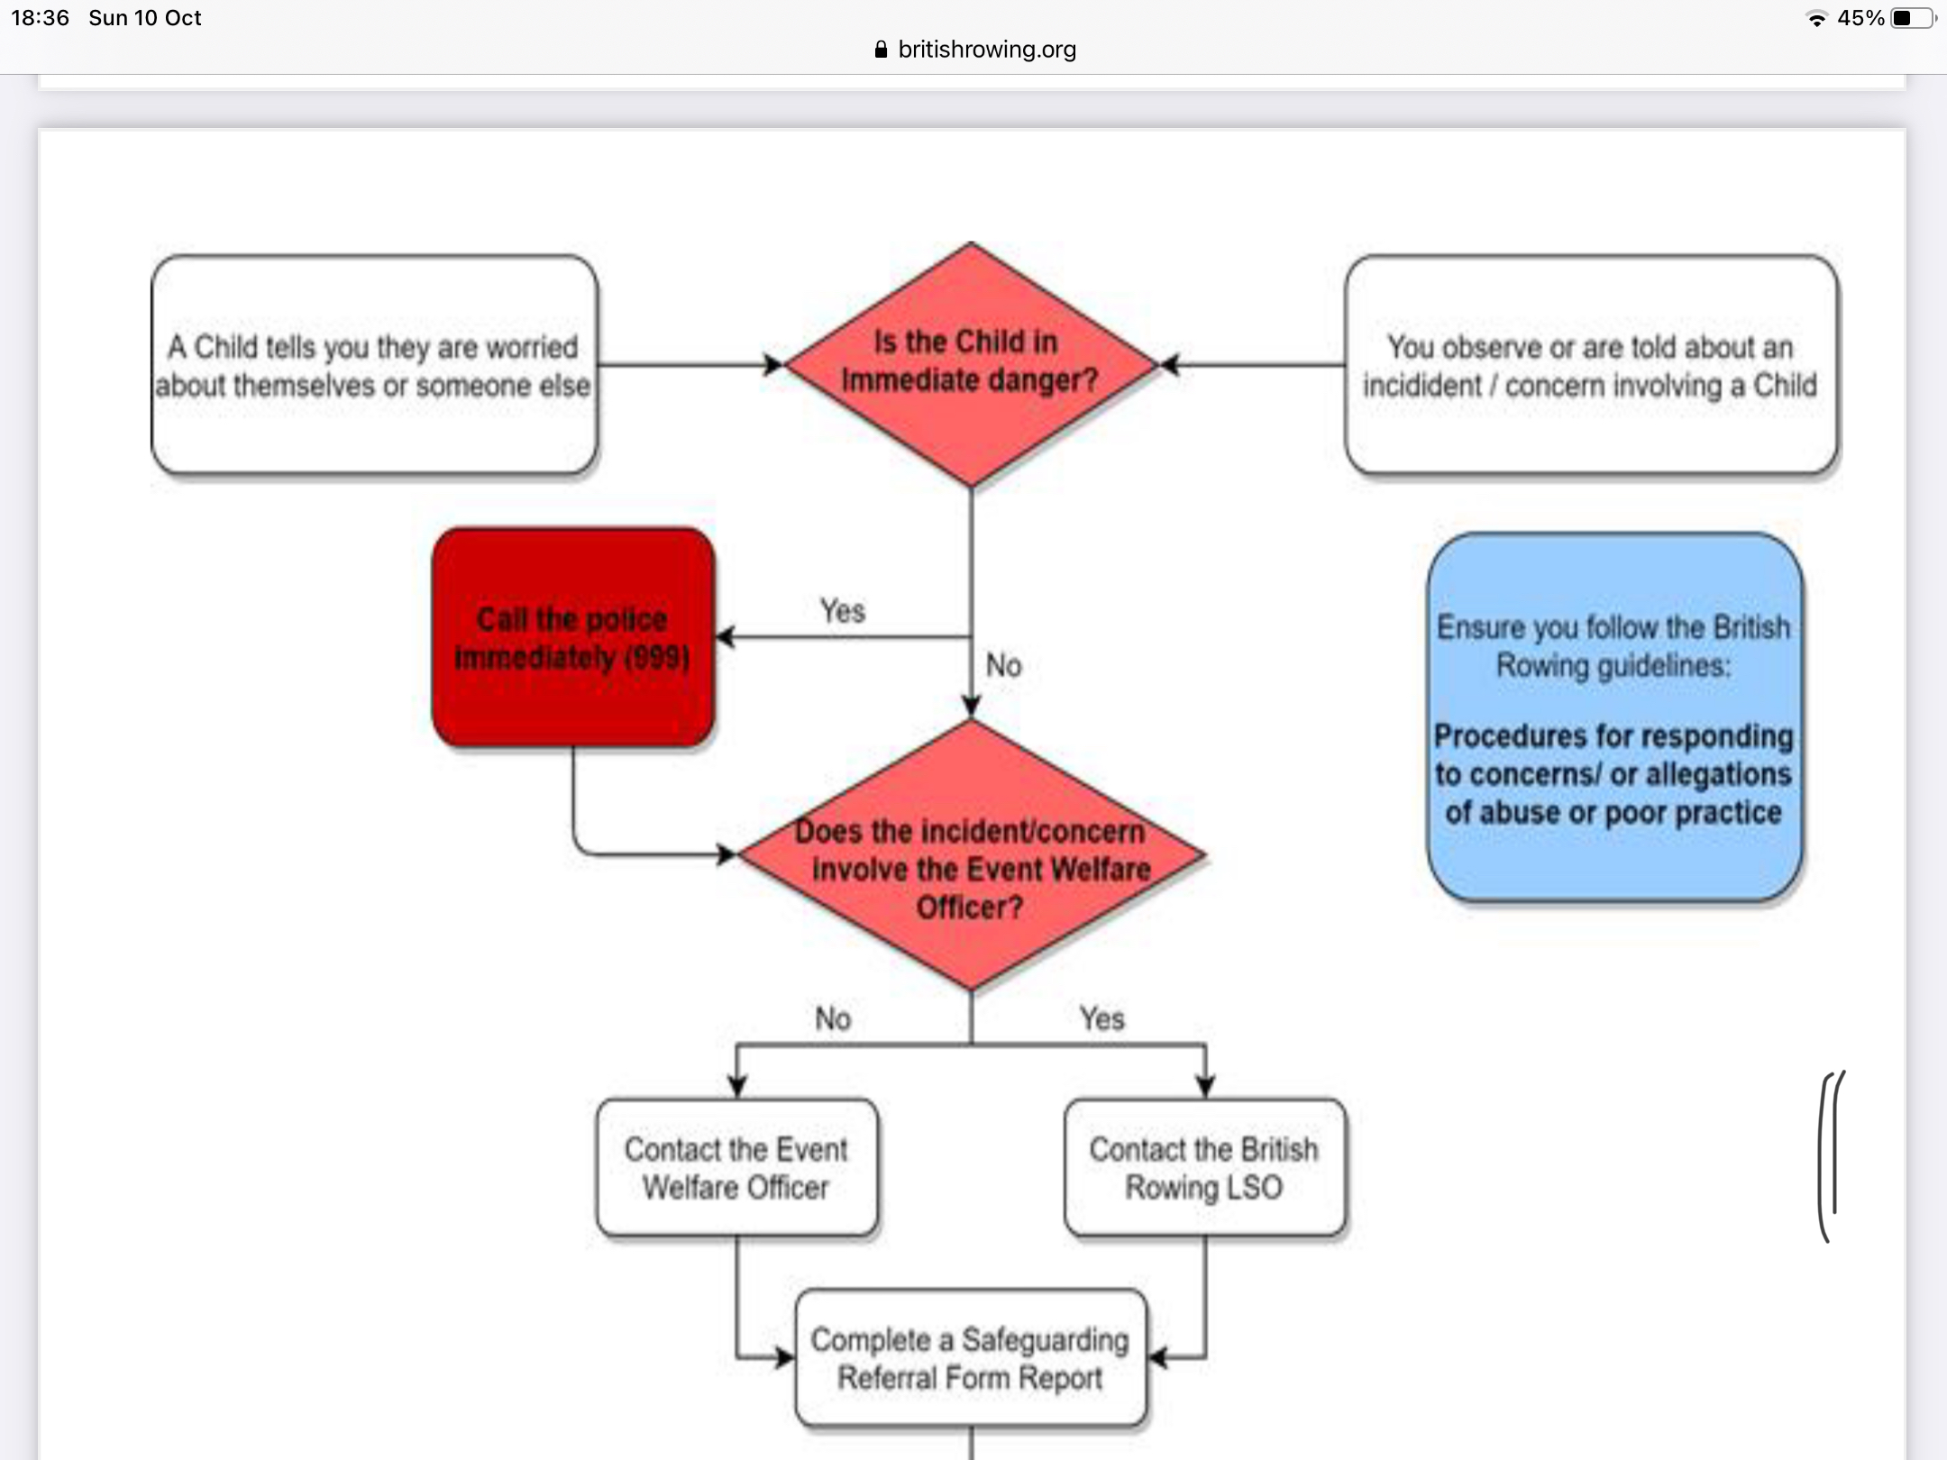
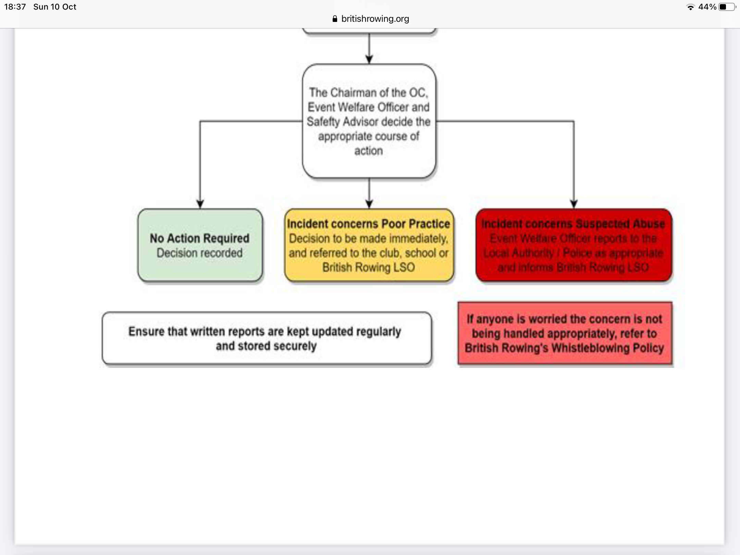

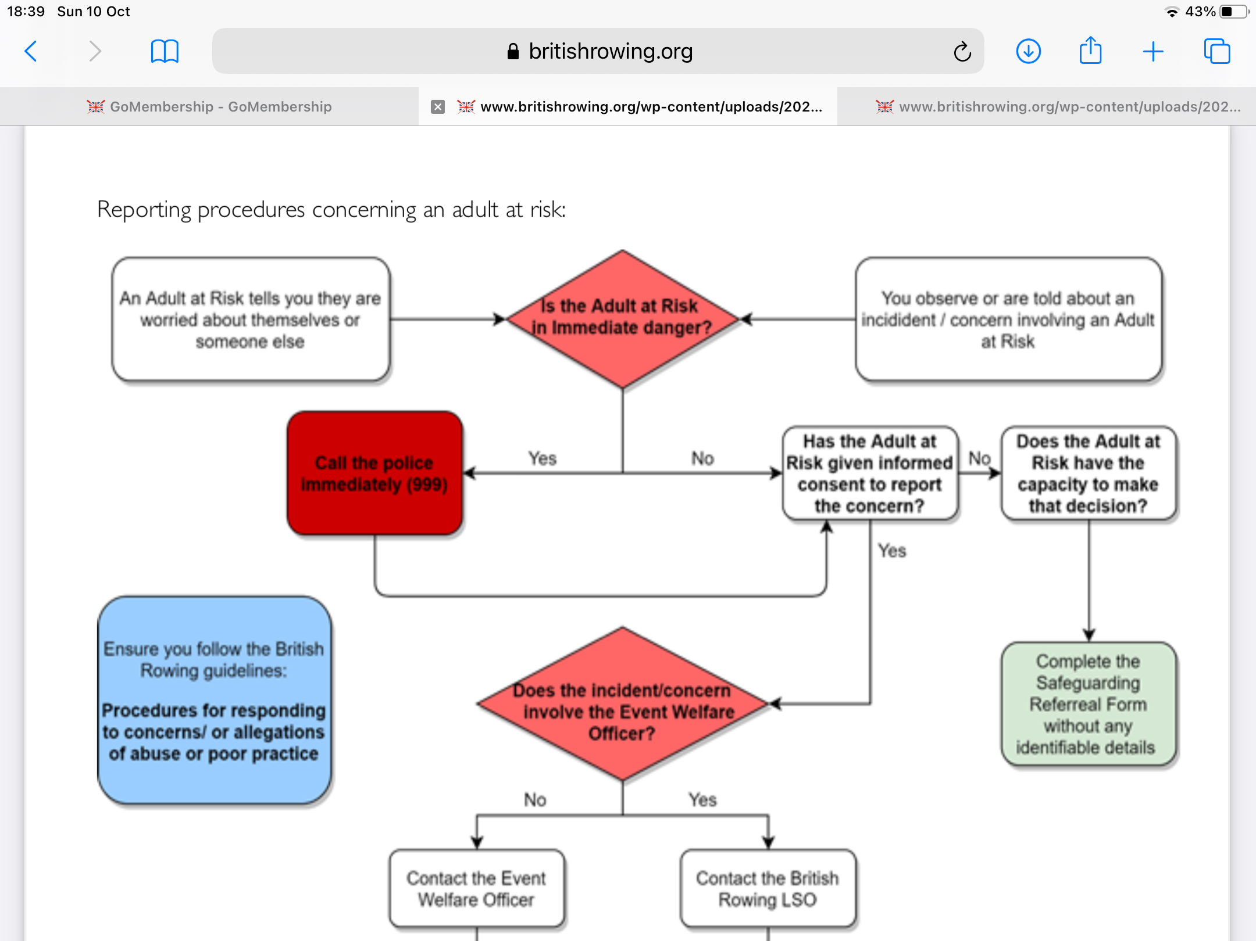
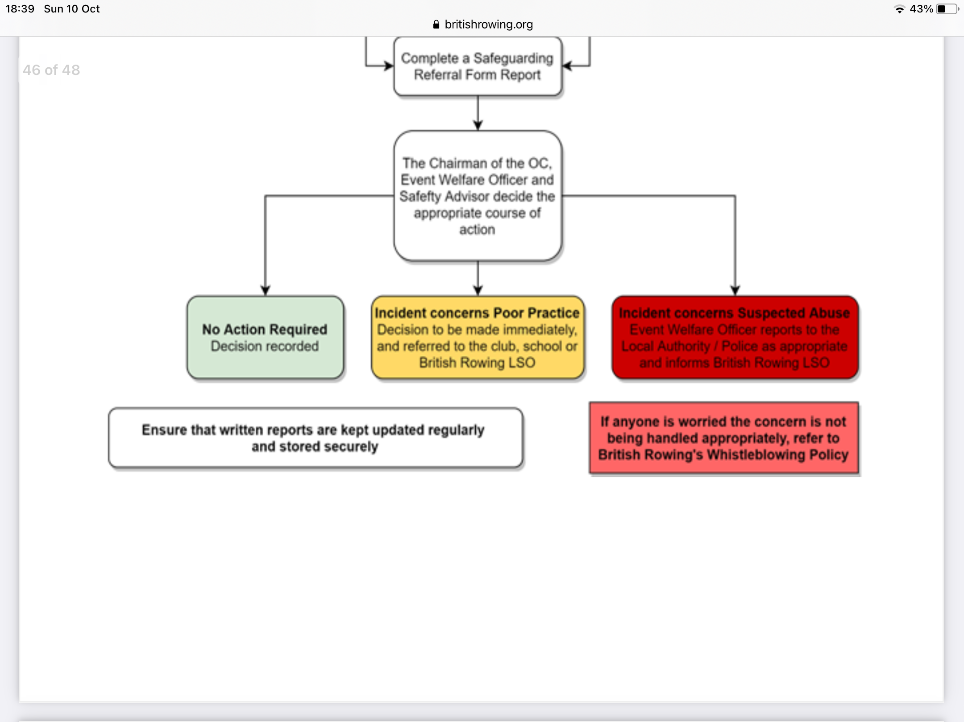

Medical provision
All medical staff will be made aware of this Policy Statement and thereby given the contact details for the Event Welfare Officer.

In an emergency the Race Committee/Safety Advisor/Welfare Officer should contact the emergency services using telephone 999

Security
Volunteers and officials should exercise vigilance for anything suspicious e.g. people taking pictures near changing facilities.

Missing persons
The designated meeting point for lost children, young people or adults at risk, will be the Race Control Room, as this will always be manned during the event.

If a person has been missing for more than 20 minutes, contact the Event Welfare Officer and/or the Event Safety Advisor via any official. If a child goes missing during the event, the following procedure should be applied:

- Officials must ensure that all other children continue to be supervised appropriately while a search for the child concerned is carried out.
- The initial report must be reported to the EWO
- The EWO will request all available officials to conduct a search of the surrounding area, allocating each individual to a specific area.
- Radio communication should convey a description of the child but not their full name
- All those searching should be told to report back in a certain time, depending on the size of the area being searched.
- If the child cannot be found after a search of the immediate surroundings, the child’s parents/carers should be contacted, via the child’s designated coach or responsible adult (as per race entry) to advise them of the concern and to reassure them that everything is being done to locate the child.
- A note should be made of the circumstances in which the child has gone missing and where he/she was last seen. A detailed physical description of the child should be prepared, including their hair and eye colour, approximate height and build and clothing he/she was wearing, as his will be required by the police.
- The concern should be reported to the police if the search is unsuccessful, no later than 20 minutes after the initial missing person report if the search is on-going.
- All officials involved, the parents, searchers, and police should be informed if at any stage the child is located.

DBS checks, access to young people or their contact details
The Entries Secretary and Registration personnel should not hold any contact details for young people and do not need to be DBS checked. DBS disclosures for medical staff and the EWO should be checked.

Any personnel having contact unsupervised with minors in an enclosed environment (if they do not hold a current DBS check) must work in pairs.

Photography and publicity
The OC recognises that at a sports event, such as [competition], many parents and supporters will wish to take photographs and all participants should be aware of this.

The British Rowing Photography Policy is available on:

https://www.britishrowing.org/wp-content/uploads/2021/09/British-Rowing-Safeguarding-Handbook-4-Safety-in-the-digital-world-Covid-guidance-template.pdf

